Pintero, Adrian Joriz G.
NW-301
Task 1:
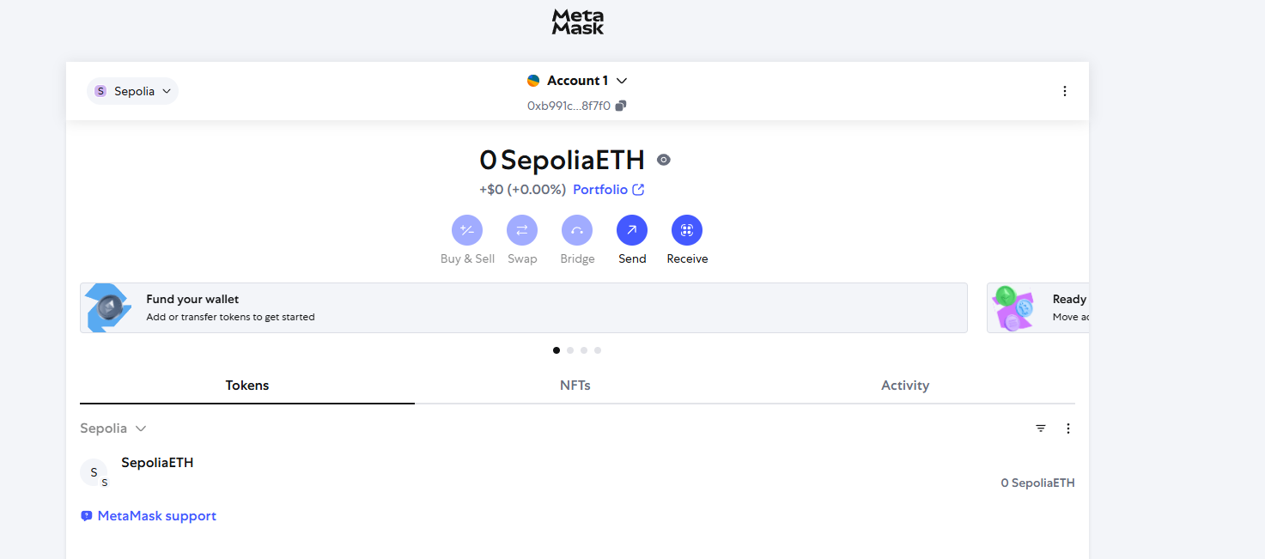
Task 2:
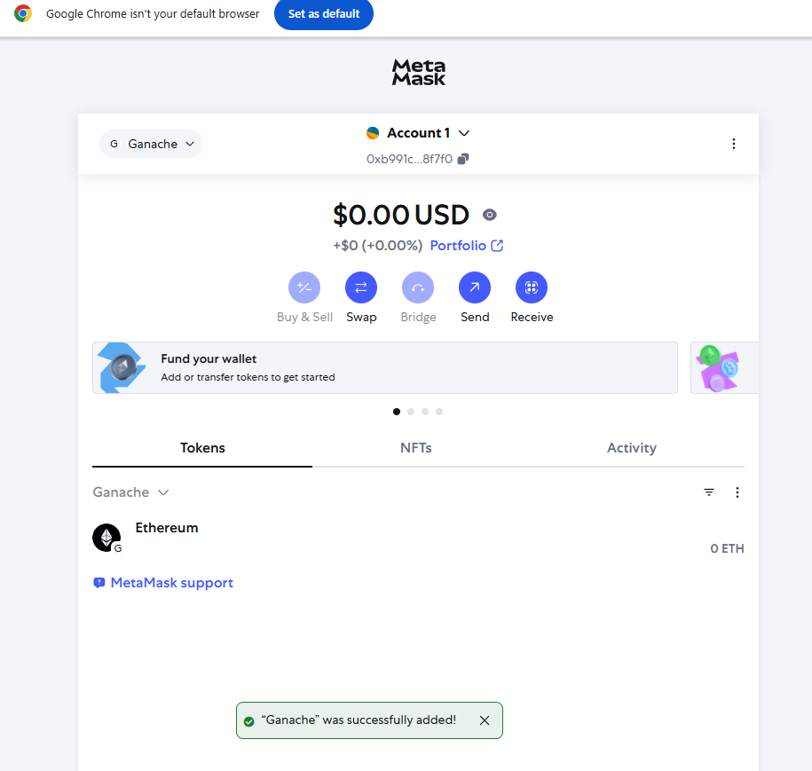

Task 3 (Running Ganache)
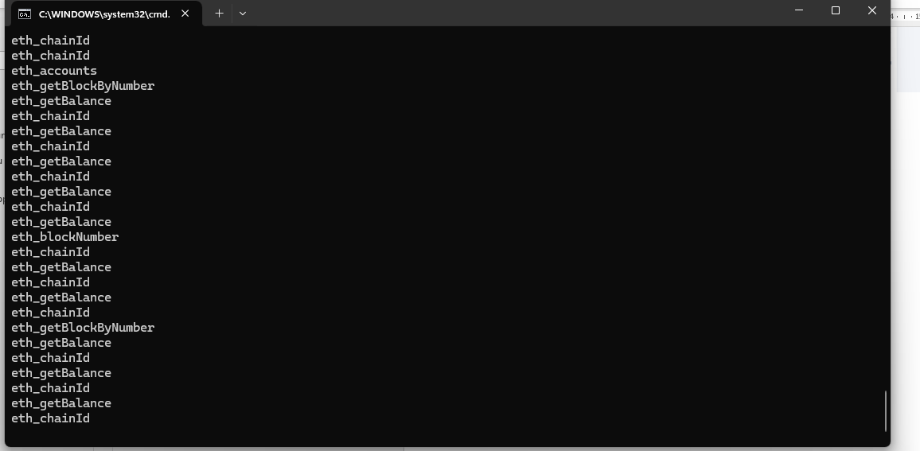
Task 4 (Remix Deployment):
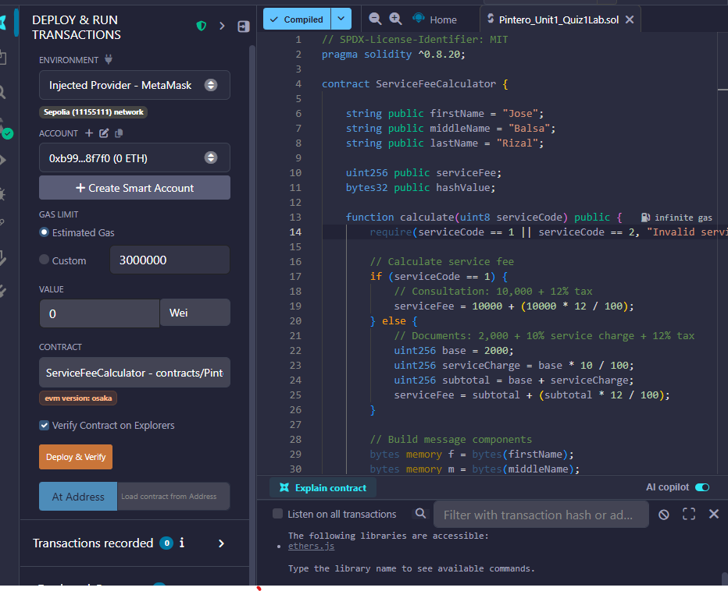


Task 5 Deployment:

